Week 3 day 3- postbreak lecture
Load balancing
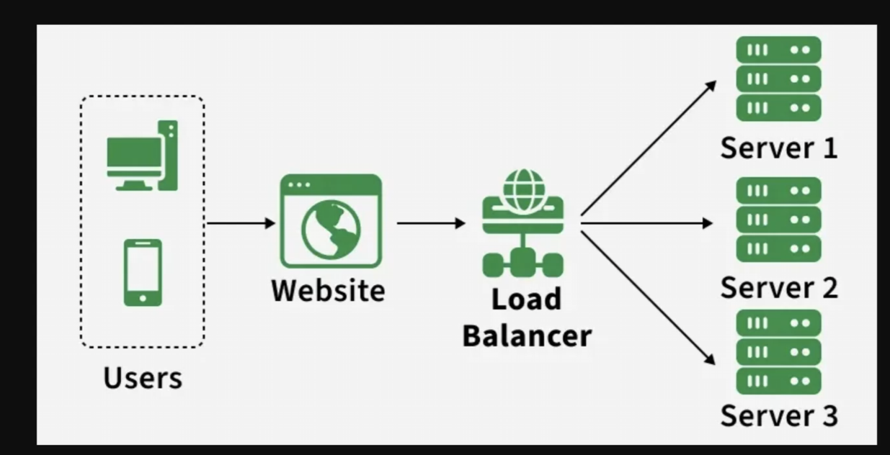

Round robin algorithm
zero downtime deployment
2 types of
Traffic manager
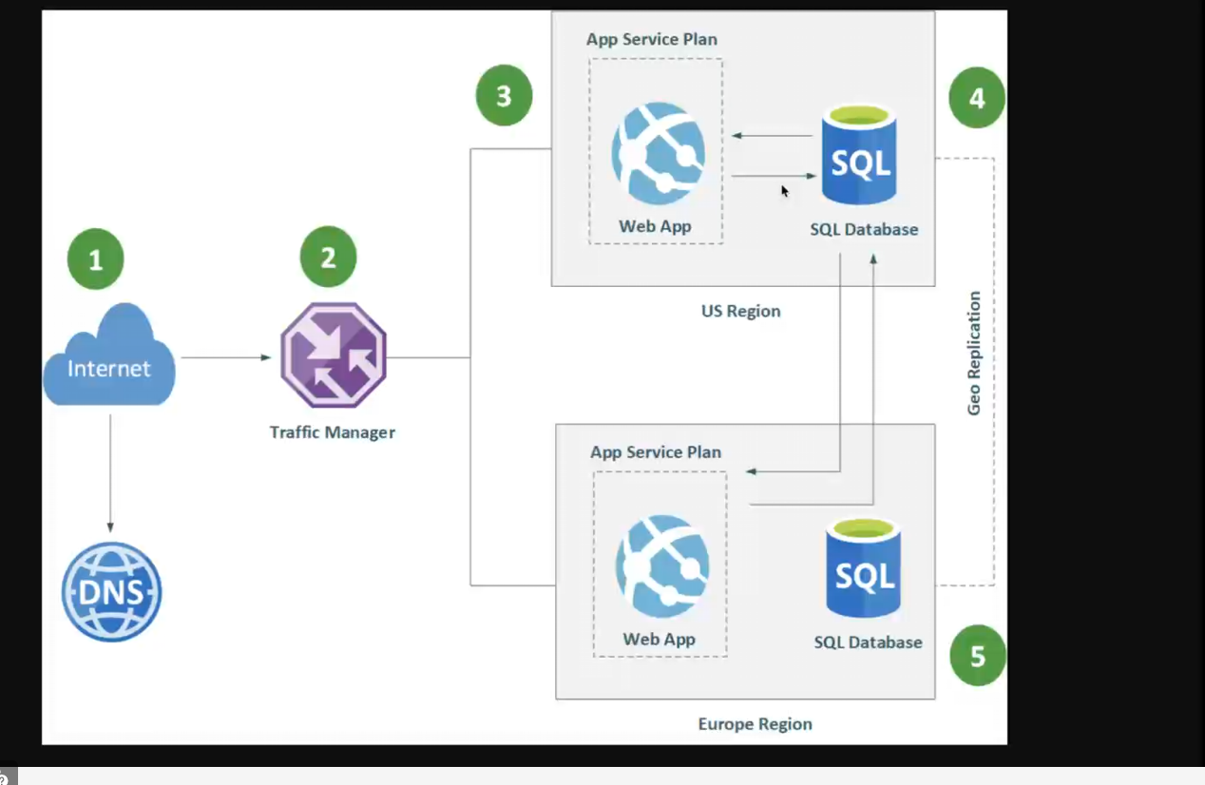

-demo: on azure portal

